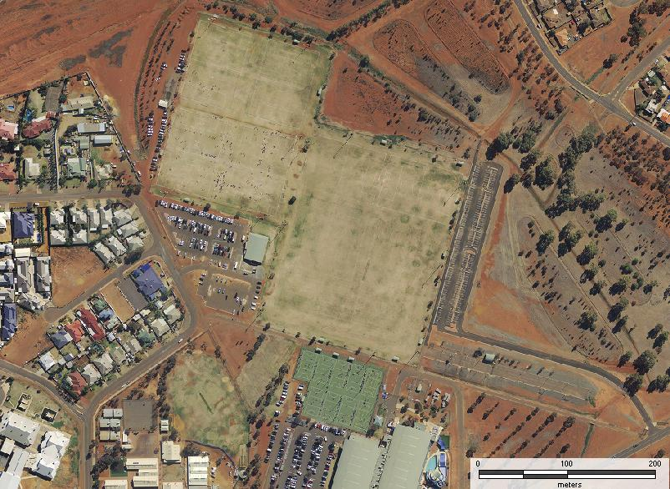
Lightning
Carnival
Map
Oasis Playing Fields

N
1
2
3
4
2
3

Soccer
Football
Netball
1
2
3
4
5
6

Outside
Touch
3
4
1
2
5
1

