E.G.C.S.S.A.
INTERSCHOOL ATHLETICS
CARNIVAL POOL B
2025

Organising School St Josephs Primary School
(With assistance from Eastern Goldfields Little Athletics)

Enquiries Elia Manu

Venue Oasis Athletics Track

Date Tuesday 23rd September 2025

Bays All competitors need to be seated under a school tent/shelter. Parents and Spectators need to stay in the spectator area.

Equipment Bring a shelter which you’ll need to set up according to the map

Awards Champion School
Meritorious School (Champion School ineligible)
Champion Boy and Girls from Year 3 to 6

Toilets Please send students in pairs for safety.

The Carnival commences at 8:00am with the Long Jump and Throw events. The running events commence at 9.30am with the 800m, followed by the sprint events and Team games. Presentations at 1.30pm and finishing at 1:45pm.

MERITORIOUS SHIELD POOL B
See Attachment at end of this document
The Meritorious Shield will be presented to the school that demonstrates the greatest overall percentage increase in total score from the previous year’s performance
* Percentages are based on total scores, not scores available to each school.

____School’s Points____________ x 100 = school’s percentage
Total awarded points Pool B

EXAMPLE:
2011 % 2012 % DIFFERENCE

Boulder 17.90 12.38 -5.52

Kambalda 14.35 16.19 1.84

St Joseph’s 17.74 18.78 1.04

INDIVIDUAL AWARDS (Champion and Runner-up)

Years 6, 5, 4, 3 BOYS
Years 6, 5, 4, 3 GIRLS
(Note: Division B races do not count towards Champion Boy/Girl points)

CHAMPIONSHIP EVENTS

Yr 6 800m, 200m, 100m, Long Jump, Turbojav
Yr 5 800m, 200m, 100m, Long Jump, Turbojav
Yr 4 800m, 200m, 80m, Long Jump, Turbojav
Yr 3 800m, 200m, 80m, Long Jump, Turbojav

TEAM GAMES

Leaderball 6 per team Yr 3/4 boys, Yr 3/4 girls, Yr 5/6 boys, Yr 5/6 girls
Passball – 8 per team Yr 3/4 boys, Yr 3/4 girls, Yr 5/6 boys, Yr 5/6 girls
Round the Marker Relay – 4 per team (Yrs 3-6 girls & Yrs 3-6 boys)
Teams are not to be coached by staff or Parents during the event

POINTS ALLOCATION (Division A and B)
1st 2nd 3rd 4th
Individual 5 3 2 1
Team Events 10 6 4 2

Lane Roster 2024 (To be changed each year)

- South Kalgoorlie
- East Kal
- G.B.C
- St Joseph’s
- Kambalda West
- Boulder
- CAPS Kurrawang

Interschool Athletics Carnival 2024
JOBS ON THE DAY

JOB TITLE | JOB DESCRIPTION | JOB
COORDINATOR | Coordinate all aspects of Carnival before and during event.  Provides First aid station at recorders station. | St Josephs
ANNOUNCER | Announces winners of each race on the podium and provides running totals. | Kam West DHS
RECORDERS | Record results, provide progressive scores and collate champion points.  Assists with scoring & presents ribbons to 1st – 4th place-getters | St Josephs (x2)  Boulder (x1)
COLLECTION  MARSHALLS | Walks along and collects athletes from the front of bays for upcoming races. | South Kalgoorlie
STARTER |  | Eastern Goldfields Little Athletics
STARTER  MARSHALL | Takes children from the collection marshal and sit them in the tent ensuring children are in their correct number line and correct race. Encourage stretching of muscles. | CAPS Kurrawang
CHIEF JUDGE |  | Eastern Goldfields Little Athletics
TIMEKEEPERS |  | Eastern Goldfields Little Athletics
PLACE JUDGES |  | Eastern Goldfields Little Athletics
PLACE  MARSHALL | Ushers all athletes to the recorders table. Directs place-getters to onto the podium and others back to their bays. | GBC
FIRST AID | Each school must have a first aid kit in their bay. | EACH SCHOOL BRINGS OWN FIRST AID KIT
BAY MARSHALLS | Have competitors seated at the front of their bays ready for collection at least 3 events in advance. They also distribute toilet passes and encourage students to participate, show positive sporting behaviour and cheer. | EACH SCHOOL PROVIDES ONE STAFF MEMBER FOR THEIR SCHOOL BAY
TEAM GAMES | Watch for disqualifications – see game rules. | PHYSICAL EDUCATION SPECIALISTS
LONG JUMP | Marshall – Get students ready and organised to start the event. See student/ school order list. Mark off.  Measurement – Measures the back of the footmark in the jump pit, calls out the measurement for the recorder.  Rake – Rake after every jump so flat. Also holds tape measure to the front of the footmark on the jump mat.  Chief Judge – Watches for no jumps (foot goes over the line). See rules. | Eastern Goldfields Little Athletics
LONG JUMP | Recorder – Record jump distance/ no jumps etc. Call out next competitor. | Boulder
TURBO -JAVELIN | Marshall – Get students ready and organised to start the event. See student/ school order list. Also watches for foot fouls (foot goes over the line)  Measurement – Measures each throw  Chief Judge – Watches for disqualifications (not correct technique). See rules. Checks measurements. | Eastern Goldfields Little Athletics
TURBO -JAVELIN | Recorder – Record throw distances. | South Kalgoorlie



LEADERBALL ( 11 inch Safety Softball )

- Teams of 6.
- First catcher will be placed 4m from the leader. Each consecutive catcher will be 1m apart.
- Start with ball on the ground in the leader’s hand.
- Leaders must keep 1 foot on their 20cm spot when throwing and catching.
- Catchers must have one foot on or next to the 10cm spot when receiving the ball. The ball must be placed on or next to the spot. Catcher then runs to the right and behind the team first and then around the leader.
- If the ball is badly thrown or dropped, the catcher must retrieve the ball and return to their spot before continuing. Other players must not touch the ball unless it is their turn. (Players must not cut through another team.)
- The leader and No. 5 must stand erect with both feet on the spot when players are running around them. Leader can relax to throwing position when the player has passed.
- Once the catcher has thrown the ball he/she is to crouch over the spot having some part of their body touching the spot.
- Under-arm or over-arm throws are permitted (or a combination of both)
- After receiving the final throw from No. 5 the leader turns and runs to the finish line. (The leader must have their foot on their spot when making the final catch). If the final throw is off target, the leader must return to their spot and step on it before running to the finish line. The leader should carry the ball with them to the finish line.

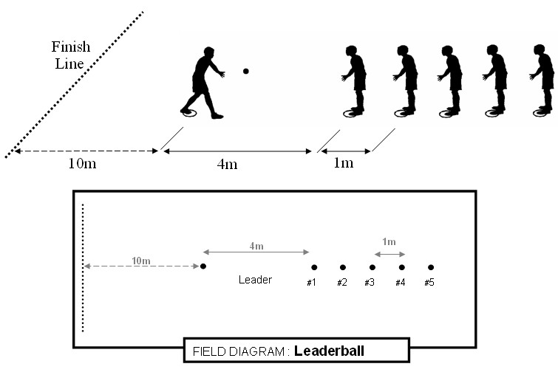

PASSBALL (Junior Basketball Size 5 or Netball)

- Teams of 8

- Start with ball on ground in leader’s hand.

- Teams of eight, see diagram for team positions.

- The ball is to be passed diagonally up and down three times, then the leader runs 10m to finish line carrying ball.

- Shoulder or chest passes only may be used. Two hands must be used to pass the ball.

- A player must have 1 foot on or behind the spot at all times. (The other foot is free to step forward while passing or receiving the ball)

- If the ball is badly thrown or dropped, the receiver must retrieve the ball and return to their spot before passing it. Players must not cut through another team and interfere with their passing. They can collect their ball when it is safe.

- After receiving the final pass, the leader turns and runs to the finish line with the ball. (The leader must have their foot on their spot when receiving the final pass). If the final pass is off target, the leader must return to their spot and step on it before running to the finish line.
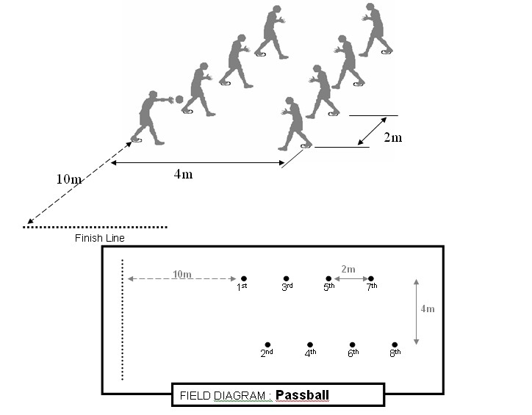

ROUND THE MARKER RELAY ( 100m Year 5-6)

- 4 runners in each team
- Runners line up behind START CONE.( facing away from the finish line )
- First runner stands in lane on left hand side of cone. [Fig. 1]
- On start, run up left lane, around TOP MARKER POLE, return in right lane and round BOTTOM MARKER POLE.
- Whilst runner is completing circuit next runner steps in to left hand lane.
- As first runner rounds BOTTOM MARKER next runner begins to move off inside the change zone.
- Runners must change baton inside the 30m change zone.
- When runner has passed on baton they proceed to the end of change zone and sit behind the SITTING CONE. ( facing the finish line ) [Fig. 2]
- When fourth runner takes baton, he/she rounds the TOP MARKER then runs straight through to the finish line. ( ie: runs past the BOTTOM MARKER and straight to the finish line ) [Fig. 3]
Watch this video example:

https://youtu.be/9f-Ez_Sk8Gc
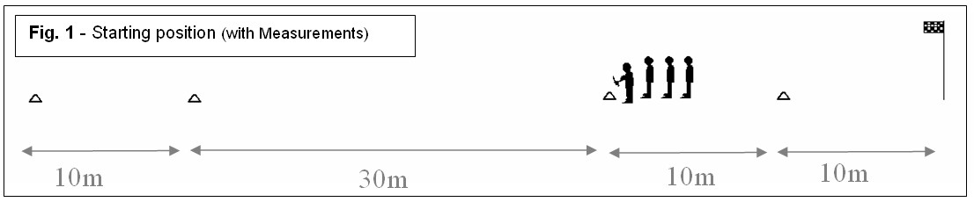
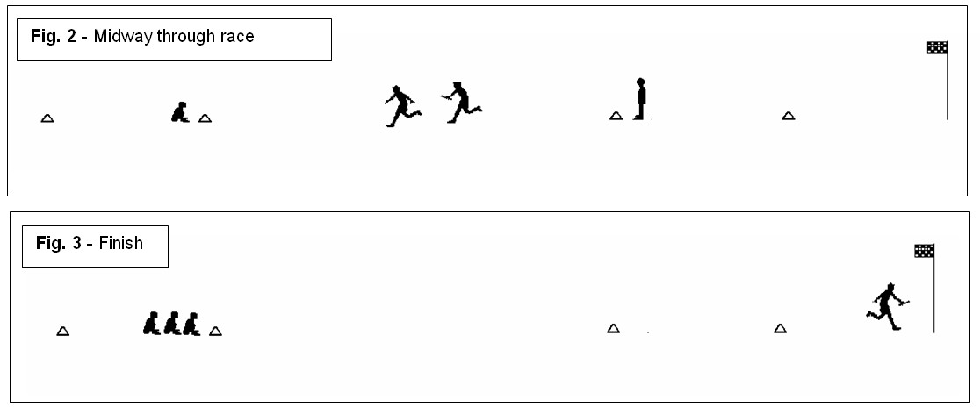
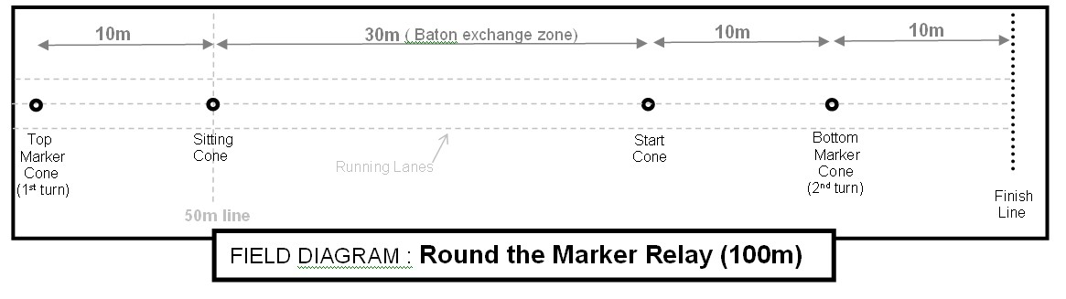
Pole
Pole

ROUND THE MARKER RELAY ( 80m Year 3-4)

- 4 runners in each team
- Runners line up behind START CONE.( facing away from the finish line )
- First runner stands in lane on left hand side of cone. [Fig. 1]
- On start, run up left lane, around TOP MARKER POLE, return in right lane and round BOTTOM MARKER POLE.
- Whilst runner is completing circuit next runner steps in to left hand lane.
- As first runner rounds BOTTOM MARKER next runner begins to move off inside the change zone.
- Runners must change baton inside the 20m change zone.
- When runner has passed on baton they proceed to the end of change zone and sit behind the SITTING CONE. ( facing the finish line ) [Fig. 2]
- When fourth runner takes baton, he/she rounds the TOP MARKER then runs straight through to the finish line. ( ie: runs past the BOTTOM MARKER and straight to the finish line ) [Fig. 3]
Watch this video example:

https://youtu.be/9f-Ez_Sk8Gc
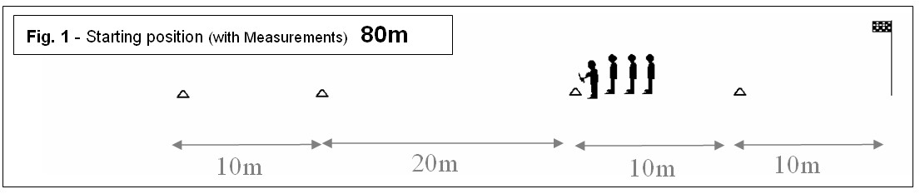
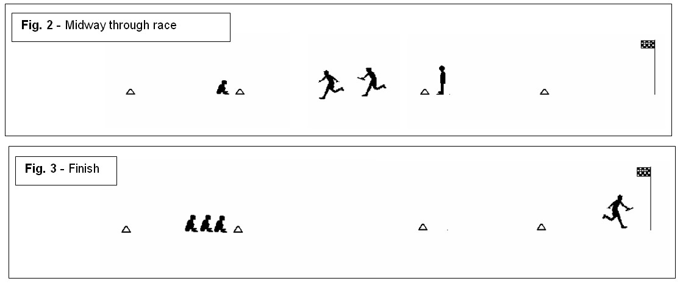
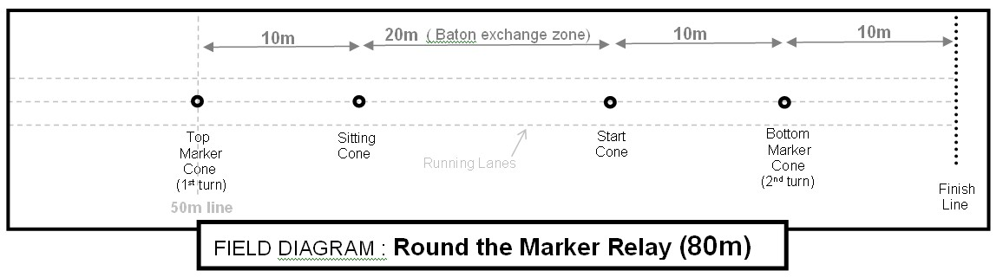
Pole
Pole

LONG JUMP

- One competitor for each age group for boys and girls.
- Take-off area is a 1m square area.
- Each competitor for 3 jumps. A “NO-JUMP” – jump that does not comply with the rules is counted as one jump.
- One false run-up is permissible, provided no jump is attempted and the competitor doesn’t reach the take-off area. Two false run-ups count as one jump.
- Competitors are to jump in the order listed by the officials.
- One trial jump may be attempted before the competition.
- The jump is to be measured between the two closest points on the mat (toe) and the pit (foot, hand or whatever body part is closer)

800m
- Two competitors for each age group for boys and girls
- Competitors start on the 200m stagger and may cross to the inside lane after they enter the straight for the first time.

TURBO JAV

- All schools will nominate only one competitor in each event.
- A 300 gram turbo jav must be used (weight standards are minimum).
- Each competitor will be allowed one practice throw prior to the start of the competition.
- Only one thrower should be on the approach area at a time.
- The turbo jav should be held by the grip with the point facing forward.
- The turbo jav must be thrown using an over-hand throwing motion of the throwing arm. ( BOWLING is not allowed ) – Use the video below for coaching.
- The thrower may not use a 360 degree turn of their body during their approach. Each thrower is allowed three non-consecutive throws. The longest measurement of the three throws will be used for scoring. Throws will be measured in meters from the inner edge of the arced-throwing restraining line.
- A thrower is allowed one minute to initiate a trial after their name is called.
- The turbo jav must land nose first. Otherwise, the throw shall be called a foul and thus not measured. (Turbo Jav may rotate end to end as long as the nose lands first)
- The thrower must throw the turbo jav within the marked lines of the athletics track. If the turbo jav lands outside the sector lines, the throw will be called a foul and thus not measured.
- A run up is permitted provided that during their approach and throw, the thrower does not step over the side lines or the foul line.
- After their throw the athlete must wait for the turbo jav to land and the official to announce MARK or FOUL before exiting to the rear of the approach.

Correct and Legal technique coaching video:
https://youtu.be/vg_jhsWj4OU

Carnivals commence at 8:00am with the Long Jump and Throw events. The running events commence at 9.30am with the 800m, followed by the sprint events and Team games. Presentations at 1.45pm and finishing at 2pm.

E.G.C.S.S.A. Meritorious shield Calculation Table

Interschool Athletics Carnival 2024 / 2025

POOL B 2024 |  |  |  |  | POOL B 2025 |  |  |  | 2023 Meritorious Results
 | SCHOOL | Points | % |  | # | SCHOOL | Points | % | % Diff | Meritorious Placing
 | St Joseph’s P.S. |  |  |  |  | St Joseph’s P.S.
 | G. B.C. |  |  |  |  | G. B.C.
 | Boulder P.S. |  |  |  |  | Boulder P.S.
 | Kam West D.H.S. |  |  |  |  | Kam West D.H.S.
 | East Kalg.P.S. |  |  |  |  | East Kalg.P.S.
 | CAPS Kurrawang |  |  |  |  | CAPS Kurrawang
 | South Kalgoorlie | - |  |  |  | South Kalgoorlie
 | Coolgardie | - |  |  |  | Coolgardie
 | Kambalda P.S. | - |  |  |  | Kambalda P.S.
 | TOTAL Points | 969 |  |  |  | TOTAL Points

To Calculate Meritorious shield

1 Write each school’s 2024 points (plus Total Points)

2 Calculate each school’s percentage
(ie: 2024 Points x 100 ÷ Total points )

3 Calculate % Difference (ie: 2024 % minus 2023 %)

4 Fill out Meritorious Placing
(A school cannot win the overall Carnival and the meritorious shield.)


Inter-school Athletics
Pool B Tent Positions 2025

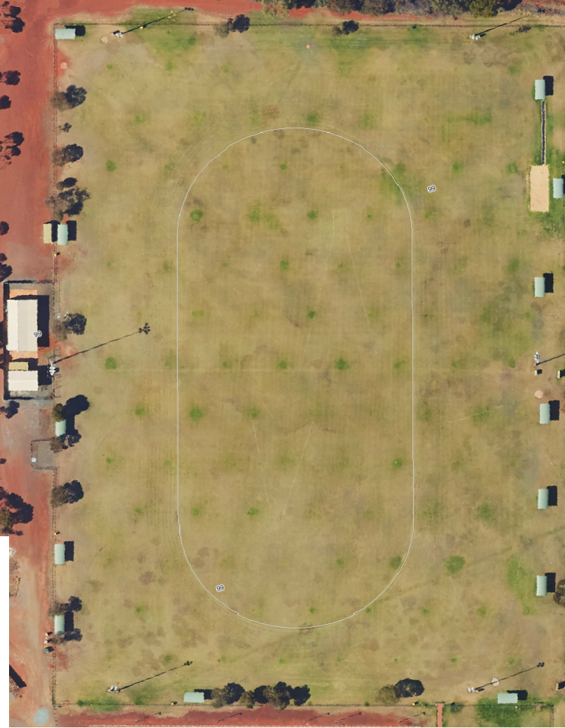
31/07/2026
East Kalgoorlie PS
Boulder PS
St Joseph’s PS
G.B.C.
CAPS Kurrawang
South Kalgoorlie PS

Kambalda West DHS

