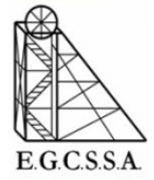

Inter-school Athletics

Pool B Tent Positions 2024

25/02/2025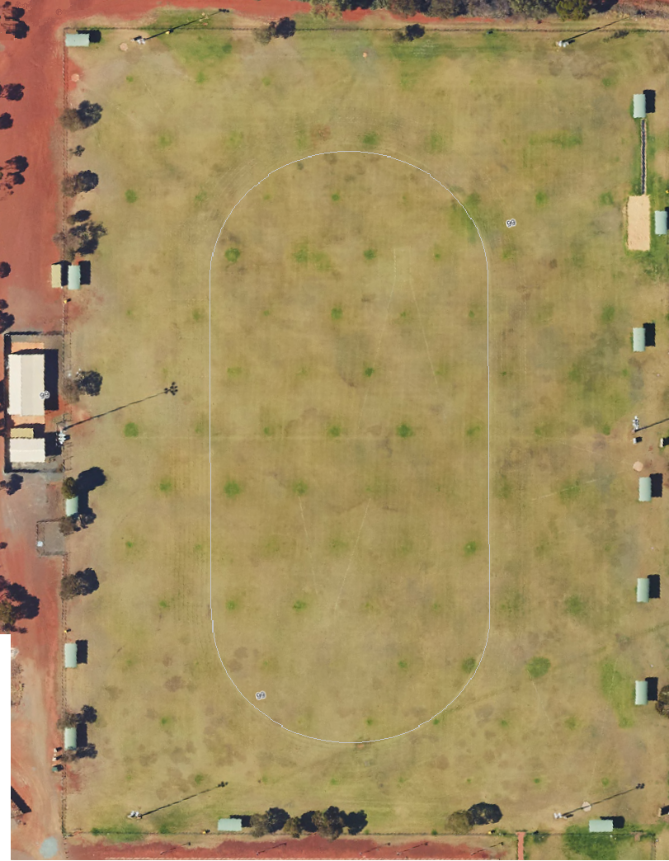

East Kalgoorlie PS

South Kalgoorlie PS

CAPS Kurrawang

Boulder PS

Kambalda West DHS

St Joseph’s PS

G.B.C.