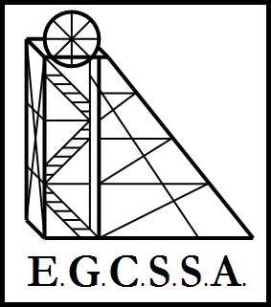

E.G.C.S.S.A.
Soccer Rules
(Pool A & B)

- Teams shall be of 5 players, with any number of substitutes.

- A system of rolling subs will be used.

- If a school has more than one team, both teams should be equal in ability. Players may not move between teams during the carnival.

- The pitch shall be the size of the junior field marked up at Oasis fields.

- Free kicks - opposing players must be 6m away from the ball. ALL free kicks must be indirect (not a shot for goal)

- There is no offside.

- Normal rules for kick off, goal kick, corners and throw-ins will apply.

- Foul play including Handball within the goal circle by defenders will result in a penalty kick from the penalty spot directly in front of goal.

- Rough play or foul language will result in a foul or sending off for repeat offenders.

________________

