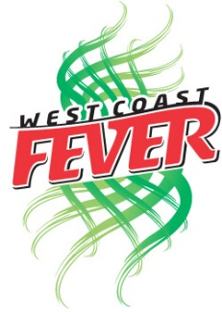**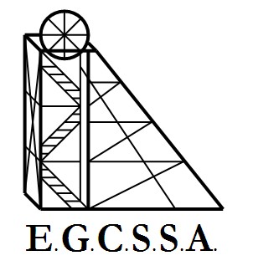Fever Cup Nominations 2025**

**Organisers: O’Connor Primary**

|  |  |  |  |  |
| --- | --- | --- | --- | --- |
| **School Name** | **Teams Nominating** | **Courts Available** | **Travel To Kambalda** | **Dates Unable to Play** |
| Kambalda Primary |  |  |  |  |
| St Mary’s |  |  |  |  |
| St Joey’s |  |  |  |  |
| Boulder |  |  |  |  |
| O’Connor |  |  |  |  |
| South Kalgoorlie |  |  |  |  |
| North Kalgoorlie |  |  |  |  |
| Kambalda West |  |  |  |  |
| Hannans |  |  |  |  |
| GBC |  |  |  |  |
| Kalgoorlie Primary |  |  |  |  |