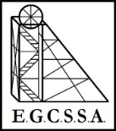
INTERSCHOOL CROSS COUNTRY CARNIVAL
Year 3 / 4 course - 1500m
Year 5 / 6 course - 2000m

Program
(Please note that times below are approximates only)

9.00 am Course marshals & officials meeting.
9.30 am Students are walked around the course

10.00 am Year 3 Girls
10.15 am Year 3 Boys
10.30am Year 4 Girls
10.45 am Year 4 Boys
11:00 am Year 5 Girls
11.15 am Year 5 Boys
11.30am Year 6 Girls
11.45 am Year 6 Boys

Presentations 12:05 pm

Finish Time 12.25pm

Individual Awards
1st Place – Champion medal
2nd Place – Runner up medal
3rd Place – Ribbon
4th Place – Ribbon

Championship Points
The first twenty place getters receive championship points
(from 20 points to 1 point).
The school with most points are awarded the championship shield
The school with the greatest improvement are awarded the Meritorious shield

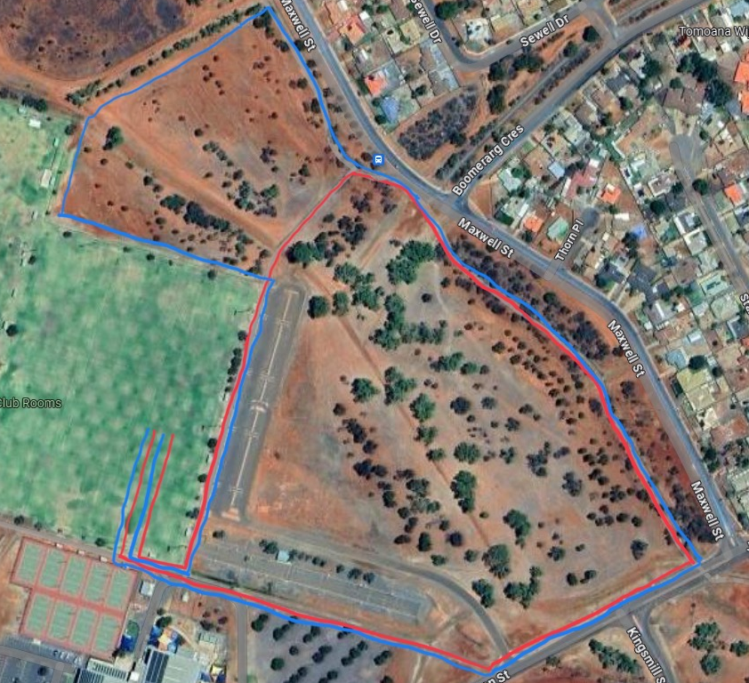
1
2
3
4
5
6*
7*
Red - Year 3&4 - 1500m
Blue – Year 5&6 - 2000m

_________

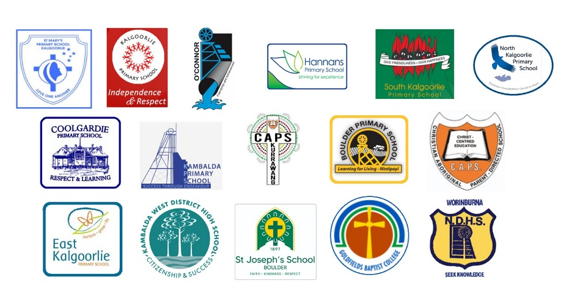

2026
E.G.C.S.S.A.
Interschool
Cross Country Carnival
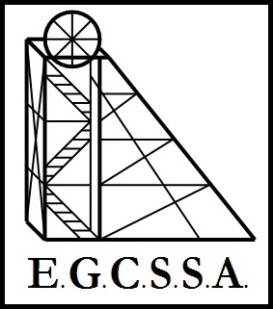
Pool A & Pool B

Friday 31st July 2026
Oasis Playing Fields, Kalgoorlie

