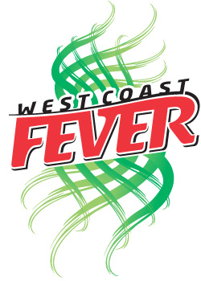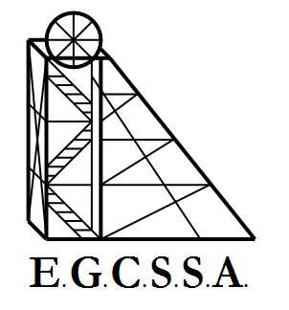

FEVER CUP

RULES, GUIDELINES & PROCEDURES

- All games will be played at school courts (this has been done with the hope of reducing travel costs & increasing the atmosphere and crowd surrounding the games)

- Schools may nominate a maximum of 2 teams.

- Score sheets should be printed out before the day.

- Points will be deducted if a player misbehaves or is sent off.

- If a school enters more than one team, they shall be equal in ability.

- Umpires will be kindly supplied by E.G.C. Stars Foundation. However Each team is responsible for providing an adult umpire if required (can also be the team’s coach).

- Each team needs: a size 5 netball, bibs (2 diff. colours if possible) and a timer each week.

- Games will start at 1:15pm sharp and conclude at 2:15 (suggest arriving at 1:05pm.

- Games will be 12 minute quarters with 3 minutes break after the 1st quarter and 3rd quarter, with a 5 minute break at half time.

- Scorecards are for individual team use only. There will be no record of results or ladder.

