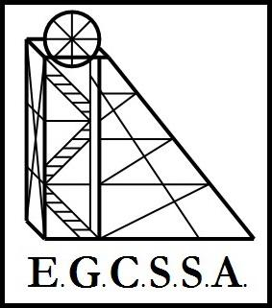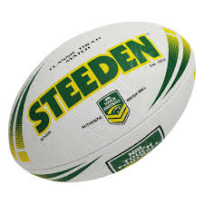**E.G.C.S.S.A.**

**Touch Rules**

**(Pool A & B)**

* Teams shall be of 6 players, with any number of substitutes.
* A system of rolling subs will be used.
* If a school has more than one team, both teams should be equal in ability. Players may

not move between teams during the carnival.

* The pitch shall be the size of the junior field marked up at Oasis fields.
* Play starts with a tap. Ball is placed on the ground (must be released by the hands) and lightly tapped with the foot then picked up. The player can then run forward and get touched or pass the ball to another player.
* Once the attacking player is touched by a defensive player they then put the ball on the ground where they were touched and step over it. (Called a roll ball).
* All passes must go in a backward direction. If the ball is dropped (ball to ground) the other team starts play with a roll ball.
* A team member then picks the ball up (they are called acting half or dummy half) and must pass backwards to another player who runs forward. (Acting half may not run with the ball. They must pass to a team member.) Once touched they place the ball on the ground and step over it etc.
* Each team is allowed 6 touches in a row as long as they don’t get penalized, drop the ball, or step out of the field. A penalty will be awarded to the other team id the ball is passed forward, if the player passes the ball after getting touched (late pass), or if the player fails to roll the ball at the mark where they were touched.
* The defence is 5 metres away from the attack (10 metres if it is a penalty) and may not move forward until the acting half has passed the ball.
* A touch down is scored when a player places the ball over the score line without being touched by a defensive player. It must be controlled and placed on the ground, not dropped. The acting half for that play cannot score.
* If the half is touched while in possession of the ball, it is a turn-over/change of possession (roll ball only).
* A touch can be made on any part of the body including clothing, hair, and the ball. (Standing on someone’s foot is classed as a touch!) Missing a player and calling “Touch” (phantom touch) is a send off offence “not in the spirit of the game”.
* Rough play or foul language will result in a foul or sending off for repeat offenders.

________________