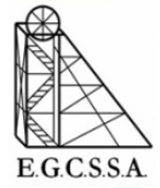

Inter-school Athletics

Pool A Tent Positions 2025

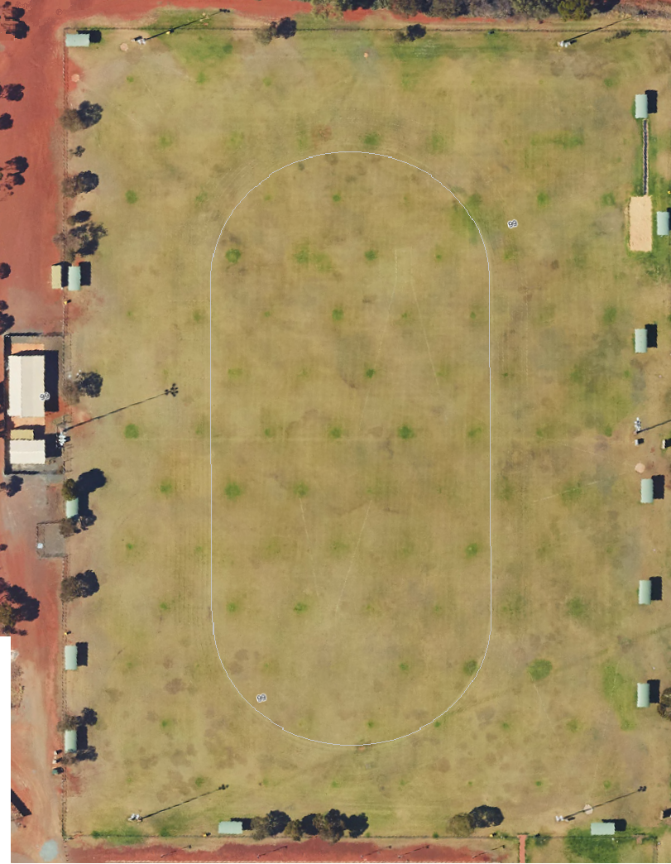

Hannans PS

North Kalgoorlie PS

Kalgoorlie PS

O’Connor PS

St Mary’s PS