2026
E.G.C.S.S.A.
Inter-school
Swimming Carnival.
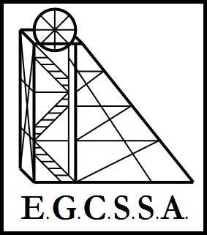

Recorders Booklet-
Championship
Medal Results

POOL A
April 1st 2026

Pool A Year 4

G I R L S | Tally | Total | PLACE | B O Y S | Tally | Total | PLACE
KALGOORLIE
O’CONNOR
ST MARY’S
NORTH KALGOORLIE
HANNANS

Pool A Year 5

G I R L S | Tally | Total | PLACE | B O Y S | Tally | Total | PLACE
KALGOORLIE
O’CONNOR
ST MARY’S
NORTH KALGOORLIE
HANNANS

Pool A Year 6

G I R L S | Tally | Total | PLACE | B O Y S | Tally | Total | PLACE
KALGOORLIE
O’CONNOR
ST MARY’S
NORTH KALGOORLIE
HANNANS

2026
Inter-school Swimming Carnival.

Pool A
2026 Year 4 Champion Girl Runner Up  Name:………………………………………  School:…………………………………….. | 2026 Year 4 Champion Girl  Name:………………………………………  School:……………………………………..
2026 Year 4 Champion Boy Runner Up  Name:………………………………………  School:…………………………………….. | 2026 Year 4 Champion Boy  Name:………………………………………  School:……………………………………..
2026 Year 5 Champion Girl Runner Up  Name:………………………………………  School:…………………………………….. | 2026 Year 5 Champion Girl  Name:………………………………………  School:……………………………………..
2026 Year 5 Champion Boy Runner Up  Name:………………………………………  School:…………………………………….. | 2026 Year 5 Champion Boy  Name:………………………………………  School:……………………………………..
2026 Year 6 Champion Girl Runner Up  Name:………………………………………  School:…………………………………….. | 2026 Year 6 Champion Girl  Name:………………………………………  School:……………………………………..
2026 Year 6 Champion Boy Runner Up  Name:………………………………………  School:…………………………………….. | 2026 Year 6 Champion Boy  Name:………………………………………  School:……………………………………..
Medal Winners

