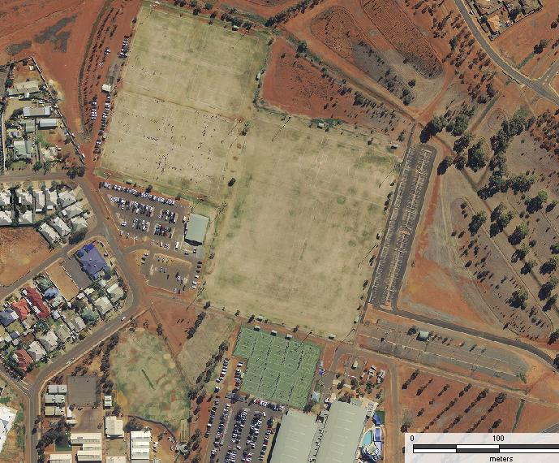
Lightning
Carnival
Map
Oasis Playing Fields

N
1
2
3
4

Soccer

Netball
1
2
3
4
5
6

Outside
Touch
3
4
1
2
5

