

ATHLETICS CARNIVAL
Team Games Rules

LEADERBALL (Year 3-6) Using an 11” Safety Softball

PASSBALL (Year 3-6) Using Basketballs or Netballs

ROUND THE MARKER RELAY (Year 3-4 - 80m )

ROUND THE MARKER RELAY (Year 5-6 - 100m )

LEADERBALL ( 11 inch Safety Softball )

- Teams of 6.
- First catcher will be placed 4m from the leader. Each consecutive catcher will be 1m apart.
- Start with ball on the ground in the leader’s hand.
- Leaders must keep 1 foot on their 20cm spot when throwing and catching.
- Catchers must have one foot on or next to the 10cm spot when receiving the ball. The ball must be placed on or next to the spot. Catcher then runs to the right and behind the team first and then around the leader.
- If the ball is badly thrown or dropped, the catcher must retrieve the ball and return to their spot before continuing. Other players must not touch the ball unless it is their turn. (Players must not cut through another team.)
- The leader and No. 5 must stand erect with both feet on the spot when players are running around them. Leader can relax to throwing position when the player has passed.
- Once the catcher has thrown the ball he/she is to crouch over the spot having some part of their body touching the spot.
- Under-arm or over-arm throws are permitted (or a combination of both)
- After receiving the final throw from No. 5 the leader turns and runs to the finish line. (The leader must have their foot on their spot when making the final catch). If the final throw is off target, the leader must return to their spot and step on it before running to the finish line. The leader should carry the ball with them to the finish line.

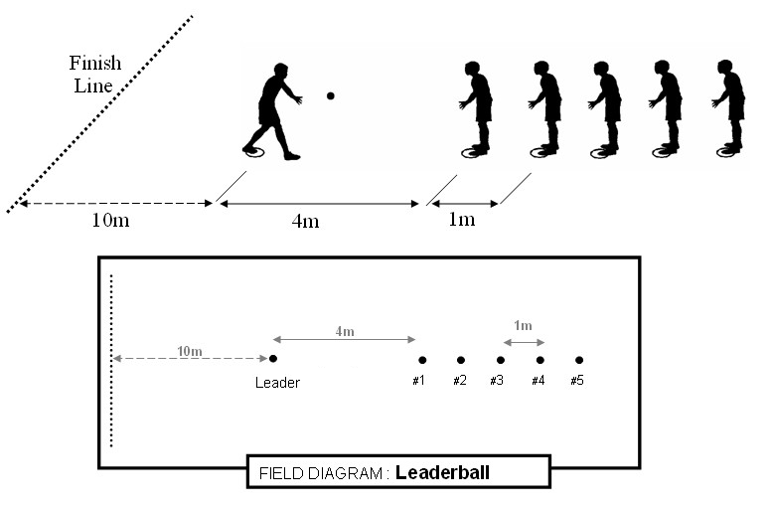

PASSBALL (Junior Basketball Size 5 or Netball)

- Teams of 8

- Start with ball on ground in leader’s hand.

- Teams of eight, see diagram for team positions.

- The ball is to be passed diagonally up and down three times, then the leader runs 10m to finish line carrying ball.

- Shoulder or chest passes only may be used. Two hands must be used to pass the ball.

- A player must have 1 foot on or behind the spot at all times. (The other foot is free to step forward while passing or receiving the ball)

- If the ball is badly thrown or dropped, the receiver must retrieve the ball and return to their spot before passing it. Players must not cut through another team and interfere with their passing. They can collect their ball when it is safe.

- After receiving the final pass, the leader turns and runs to the finish line with the ball. (The leader must have their foot on their spot when receiving the final pass). If the final pass is off target, the leader must return to their spot and step on it before running to the finish line.
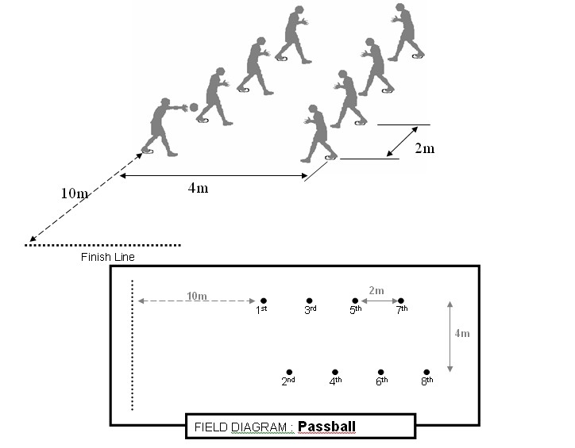

ROUND THE MARKER RELAY ( 100m Year 5-6)

- 4 runners in each team
- Runners line up behind START CONE.( facing away from the finish line )
- First runner stands in lane on left hand side of cone. [Fig. 1]
- On start, run up left lane, around TOP MARKER POLE, return in right lane and round BOTTOM MARKER POLE.
- Whilst runner is completing circuit next runner steps in to left hand lane.
- As first runner rounds BOTTOM MARKER next runner begins to move off inside the change zone.
- Runners must change baton inside the 30m change zone.
- When runner has passed on baton they proceed to the end of change zone and sit behind the SITTING CONE. ( facing the finish line ) [Fig. 2]
- When fourth runner takes baton, he/she rounds the TOP MARKER then runs straight through to the finish line. ( ie: runs past the BOTTOM MARKER and straight to the finish line ) [Fig. 3]
Watch this video example:

https://youtu.be/9f-Ez_Sk8Gc
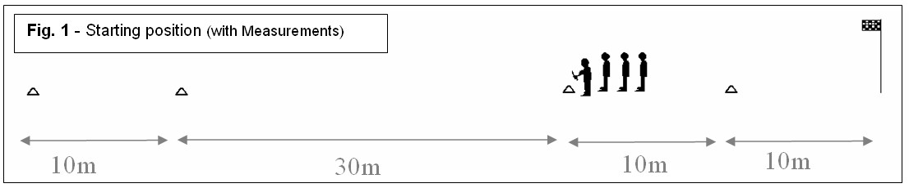
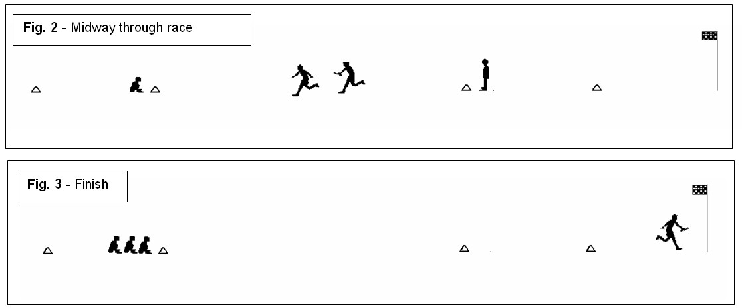
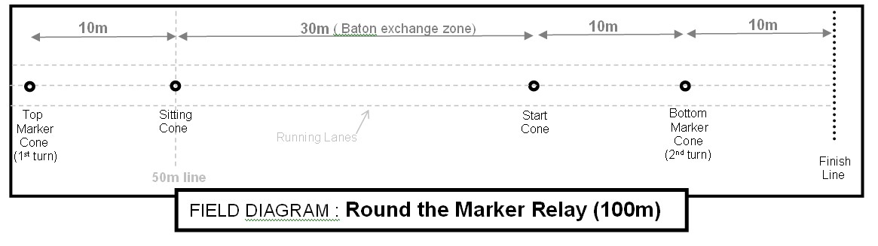
Pole
Pole

ROUND THE MARKER RELAY ( 80m Year 3-4)

- 4 runners in each team
- Runners line up behind START CONE.( facing away from the finish line )
- First runner stands in lane on left hand side of cone. [Fig. 1]
- On start, run up left lane, around TOP MARKER POLE, return in right lane and round BOTTOM MARKER POLE.
- Whilst runner is completing circuit next runner steps in to left hand lane.
- As first runner rounds BOTTOM MARKER next runner begins to move off inside the change zone.
- Runners must change baton inside the 20m change zone.
- When runner has passed on baton they proceed to the end of change zone and sit behind the SITTING CONE. ( facing the finish line ) [Fig. 2]
- When fourth runner takes baton, he/she rounds the TOP MARKER then runs straight through to the finish line. ( ie: runs past the BOTTOM MARKER and straight to the finish line ) [Fig. 3]
Watch this video example:

https://youtu.be/9f-Ez_Sk8Gc
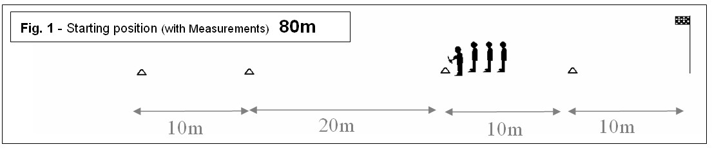
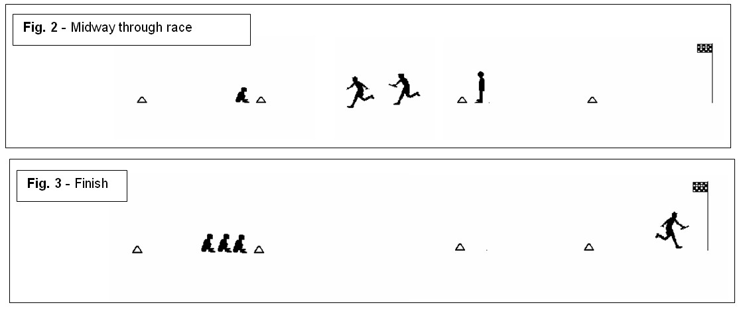
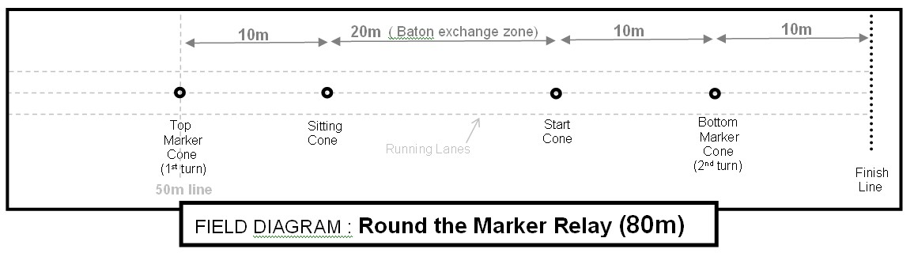
Pole
Pole

LONG JUMP

- One competitor for each age group for boys and girls.
- Take-off area is a 1m square area.
- Each competitor for 3 jumps. A “NO-JUMP” – jump that does not comply with the rules is counted as one jump.
- One false run-up is permissible, provided no jump is attempted and the competitor doesn’t reach the take-off area. Two false run-ups count as one jump.
- Competitors are to jump in the order listed by the officials.
- One trial jump may be attempted before the competition.
- The jump is to be measured between the two closest points on the mat (toe) and the pit (foot, hand or whatever body part is closer)

800m
- Two competitors for each age group for boys and girls
- Competitors start on the 200m stagger and may cross to the inside lane after they enter the straight for the first time.

TURBO JAV

- All schools will nominate only one competitor in each event.
- A 300 gram turbo jav must be used (weight standards are minimum).
- Each competitor will be allowed one practice throw prior to the start of the competition.
- Only one thrower should be on the approach area at a time.
- The turbo jav should be held by the grip with the point facing forward.
- The turbo jav must be thrown using an over-hand throwing motion of the throwing arm. ( BOWLING is not allowed ) – Use the video below for coaching.
- The thrower may not use a 360 degree turn of their body during their approach. Each thrower is allowed three non consecutive throws. The longest measurement of the three throws will be used for scoring. Throws will be measured in meters from the inner edge of the arced-throwing restraining line.
- A thrower is allowed one minute to initiate a trial after their name is called.
- The turbo jav must land nose first. Otherwise, the throw shall be called a foul and thus not measured. (Turbo Jav may rotate end to end as long as the nose lands first)
- The thrower must throw the turbo jav within the marked lines of the athletics track. If the turbo jav lands outside the sector lines, the throw will be called a foul and thus not measured.
- A run up is permitted provided that during their approach and throw, the thrower does not step over the side lines or the foul line.
- After their throw the athlete must wait for the turbo jav to land and the official to announce MARK or FOUL before exiting to the rear of the approach.

Correct and Legal technique coaching video:
https://youtu.be/vg_jhsWj4OU

Carnivals commence at 7.30am with the Long Jump and Throw events. The running events commence at 9.30am with the 800m, followed by the sprint events and Team games. Presentations at 1.45pm and finishing at 2pm.

