
EGCSSA Summer Lightning Carnival - SPORT

Cricket | Tennis | Basketball | Tee Ball
Kalgoorlie Primary School  Sarah Cosh | O’Connor PS  Stewart Smith | Hannans PS  Amanda Jenkins | St Josephs PS  Emma McFall

Overall Guidelines
Key Objective:
- Participations and engagement in physical activity and enjoyment.

Teams:
- Schools who send more than one team to a sport, must ensure that their teams should be of as equal ability as possible.
- It is a predominantly year 5 and 6 event.
- Each team must have an adult or teacher supervising them. It is also asked that each school sends a teacher to each of the sports so as to adequately cover accountability requirements.
- Each team will require a coach, scorer and umpire per game (but this can all be the same person)
- Where schools have entered more than one team in any given sport, players must stay in the one team for the entire day, they can not play across groups. Offending schools will forfeit for those matches.

“E.G.C.S.S.A. Interschool Sports are played in the spirit of inclusion, participation and fairness. Umpires are working as volunteers and must be treated with respect at all times”.
(The statement above could be included on Permission slips if deemed appropriate by your Principal)

Procedures for the day:
- Schools are asked to arrive at the venues by 9:15am.
- All fixtures will begin at 9.30 am sharp. Make sure that students involved on the first fixture are first off the bus.
- At the commencement of each game, the scoresheet for that fixture will be required to be collected from the co-ordinators desk by the team mentioned first.
- All sports are played as per the rules supplied to the schools. Please make sure your parents/ coaches are aware of this.
- Students will have a set lunch break as per fixtures. (Students are encouraged to bring from home healthy snacks and lunches, as well as a water bottle)
- There will be no finals, instead a progressive tally system is used.
- Presentations will be held separately at each of the sports at 1:50pm. A small trophy will be awarded to the winning team from each sport. The carnival will conclude by 2:00pm.
- Umpires: JPC will kindly supply umpires for the sports

2026 Venues
Tee-Ball: Oasis Playing Fields
Basketball: Evolution Mining Basketball Stadium
Cricket: Shepherdson Park
Tennis: Tennis Club (next to Shepherdson park)

Equipment List
Every school needs to supply the following equipment:
Tee Ball - 4 bases (including 1 home base),Tee-ball Tee, 1 -2 Tee Balls
(Your teams will also need bats, helmets and gloves)
Basketball - 2 Basketballs
Tennis - Tennis Equipment – Racquets for each player
Cricket – Equipment is supplied
SHADE & Sunscreen
First-Aid Kit
Drinking water
Pencils and clip board (for marking scorecards)

Inclement weather:
Decisions will be made at 7:30am on the day and schools will be notified by the co-ordinating school if the event is to be cancelled.
The following two pages are specific information for the 2026 coordinating schools
Instructions for Coordinators:
Sport coordinators are responsible for:
- Purchasing a Trophy
- Collecting Nominations
- Creating and distributing fixtures
- Pre-set-up and Marking of fields
- Collection of results and tallying of results
- Timekeeping
- Dealing with rule discrepancies
- Pick up Toilet Keys/Codes from Council Office ($55.00 deposit may be required)
Note: 2026 Oval / Field Bookings have been confirmed by Matt
Supplying the following:
- A First Aid Kit
- Hooter or Siren
- Timing Equipment
- A copy of fixtures for the umpires Scorecards, Tally sheets etc.
- (A chair, shade cover and folding table would be useful)
- Sunscreen
It is your responsibility to do the following:
- Coordinators need to supply fixtures and scoresheets for their events.
- Make sure you have enough umpires on the day
- Communicate with participating schools at all times.
Coordinators should give instructions to all Students, Staff and Parents before the start of play and include the following statement:
“E.G.C.S.S.A. Interschool Sports are played in the spirit of inclusion, participation and fairness. Umpires are working as volunteers and must be treated with respect at all times”.
On the Day
Set Up:
- look at the map and position yourself in the middle of your sports fields.
- Stay put in this one spot so you are easily accessible if needed. (Suggestion to bring along chair, shade cover and fold up table).
Scoring:
- the team mentioned first on each fixture should come to you and pick up their score cards. (Otherwise you need to deliver to them)
- this team is then in charge of returning the score card back to you at the end of the round.
- Each sport will compile a progressive tally from the 5 games (3 points for a win, 1 for a loss and 2 for a draw). There will be no finals or grand finals – in the case of 2 schools drawing in the progressive tally it is up to the sports coordinating school to go back through each game and see which team scored the most goals and points.
- Keep all the score cards safely in your folder.
- Sports co-ordinators at each ground are responsible for any rule discrepancies, collection and tallying of results.
- Please use final placing sheets, so that an overall record can be kept and distributed after the event.
Timing:
- Blow a horn/buzzer/whistle according to the times on the fixtures sheets. (All sports run to these times)
Please ensure that the timing is monitored and that all games finish on time.
Presentations:
- Round 5 finishes at 1:35.
- There is then 15 minutes for each sport to pack up and relocate themselves to the presentations area (each sport has separate presentations).
- Presentations at 1:50 (trophy awarded to the school that wins each sport).
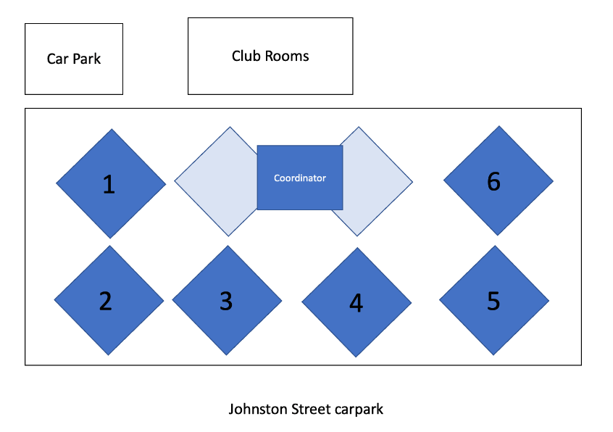
- Back on buses at 2:00pm.

Tee-Ball Field Set up

