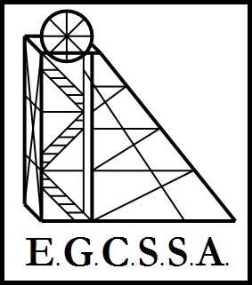
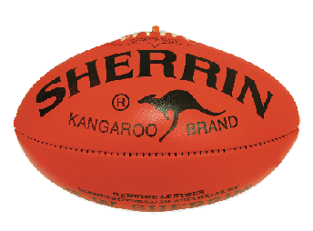
E.G.C.S.S.A.
Football Rules
(Pool A & B)

- Fifteen players a side ( no ruck, ruck/rover, rover )

- Unlimited number of interchange players.

- Games will be played over two 15 minute halves.

- For a "ball-up" the umpire will pick two players of approximately the same size.

- If the ball goes out of bounds from a kick a free kick shall be awarded to the nearest opponent.

- If the ball goes out of bounds off hands or body, the umpire calls a ball up as above.

- Limit of two bounces, the player must then dispose of the ball by hand or foot.

- A player can bump a player in the side only and push a player in the side. There is strictly NO SHIRTFRONT.

- There is no sling tackling or dragging of players to the ground allowed. ONLY wrap around tackling is permitted.

- Deliberate soccering of the ball is not permitted. A free kick shall be awarded.

- The ball must travel at least 10m for a mark to be awarded.

- A player can shepherd an opponent within 5m of the ball.

- Swearing or unduly rough play will not be tolerated. Umpires will have the right to send a player from the field. If this occurs, the player may be replaced, but the offending player will not be allowed to play again for the rest of the match.
_______________

