2026
EGCSSA
Inter-school
Swimming Carnival.
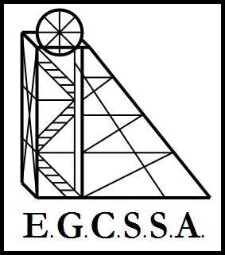

Recorders Booklet-
Championship
Medal Results

POOL B
Wednesday 1st of April 2026

Pool B Year 4

G I R L S | Tally | Total | PLACE | B O Y S | Tally | Total | PLACE
SOUTH KALGOORLIE
ST JOSEPH’S
KAMBALDA WEST
G.B.C.
EAST KALGOORLIE

Pool B Year 5

G I R L S | Tally | Total | PLACE | B O Y S | Tally | Total | PLACE
SOUTH KALGOORLIE
ST JOSEPH’S
KAMBALDA WEST
G.B.C.
EAST KALGOORLIE

Pool B Year 6

G I R L S | Tally | Total | PLACE | B O Y S | Tally | Total | PLACE
SOUTH KALGOORLIE
ST JOSEPH’S
KAMBALDA WEST
G.B.C.
EAST KALGOORLIE

2026
Inter-school Swimming Carnival.

Pool B
2026 Year 4 Champion Girl Runner Up  Name:………………………………………  School:…………………………………….. | 2026 Year 4 Champion Girl  Name:………………………………………  School:……………………………………..
2026 Year 4 Champion Boy Runner Up  Name:………………………………………  School:…………………………………….. | 2026 Year 4 Champion Boy  Name:………………………………………  School:……………………………………..
2026 Year 5 Champion Girl Runner Up  Name:………………………………………  School:…………………………………….. | 2026 Year 5 Champion Girl  Name:………………………………………  School:……………………………………..
2026 Year 5 Champion Boy Runner Up  Name:………………………………………  School:…………………………………….. | 2026 Year 5 Champion Boy  Name:………………………………………  School:……………………………………..
2026 Year 6 Champion Girl Runner Up  Name:………………………………………  School:…………………………………….. | 2026 Year 6 Champion Girl  Name:………………………………………  School:……………………………………..
2026 Year 6 Champion Boy Runner Up  Name:………………………………………  School:…………………………………….. | 2026 Year 6 Champion Boy  Name:………………………………………  School:……………………………………..
Medal Winners

